**Assignment No:-10**

Name:-Suryawanshi Sangramsingh Sambhaji

Batch: - Delta - DCA (Java) 2024 Date:-15/5/2024

**1. Write a java program to input a number and check inputted number is Krishnamurthy number or not.**

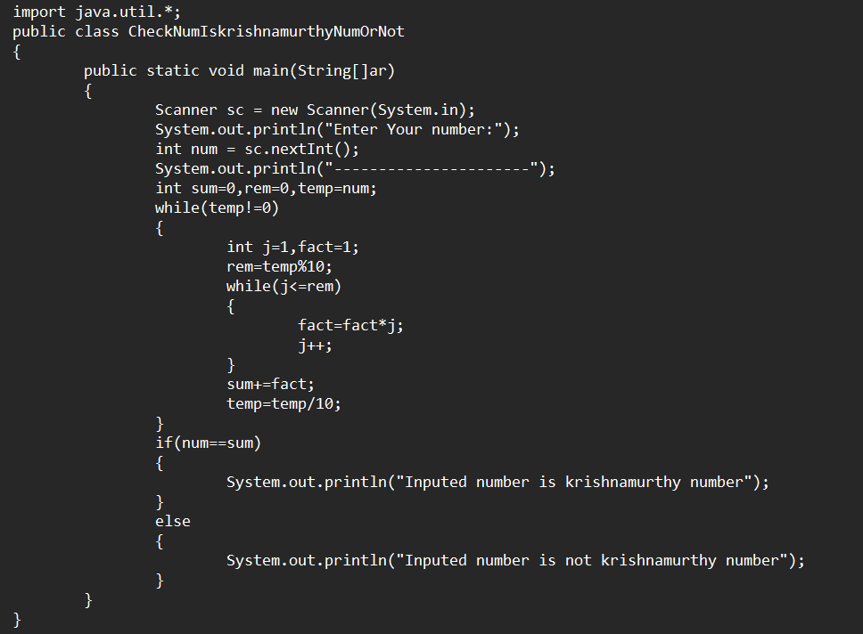

**Output:**

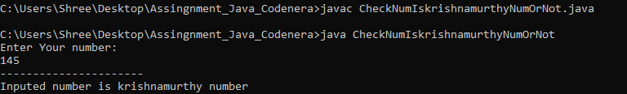

**2. Write a Java program to find the sum of the prime numbers between 100 and 200, but only consider the prime numbers that have a digit sum greater than 10. Print the sum of those prime numbers.**

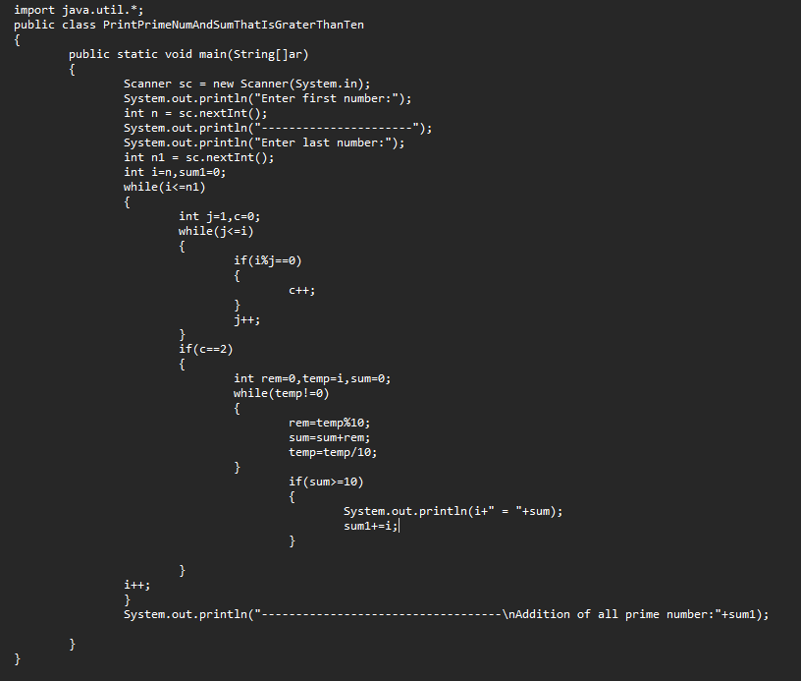

**Output:**

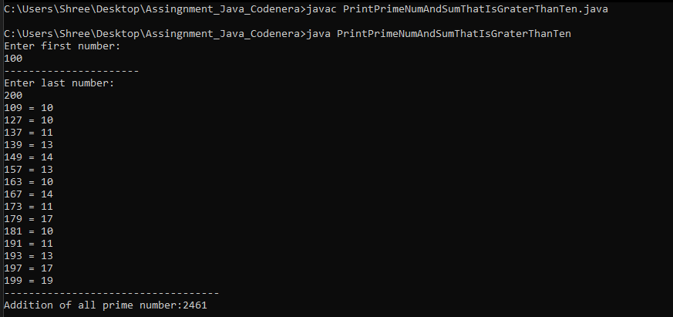

**3.** **Write a Java program to check whether a number is an automorphic number or not.**

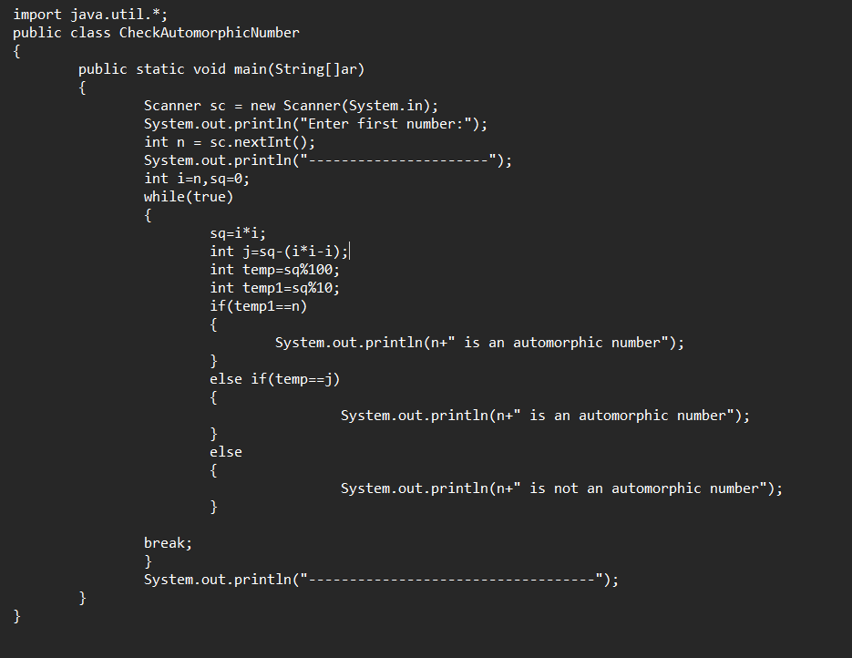

**Output:**

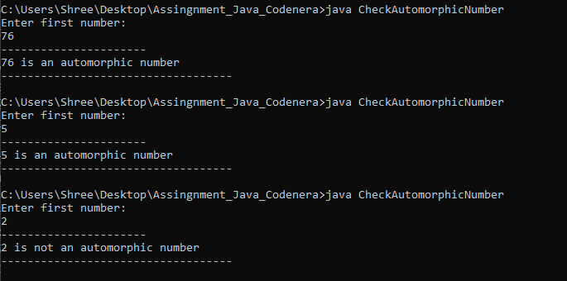

**4.**  **Write a Java program to check whether a number is a Duck Number or not.**

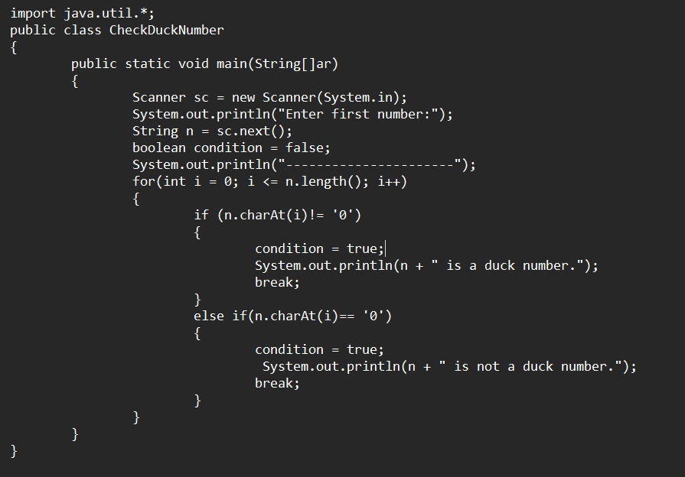

**Output:**

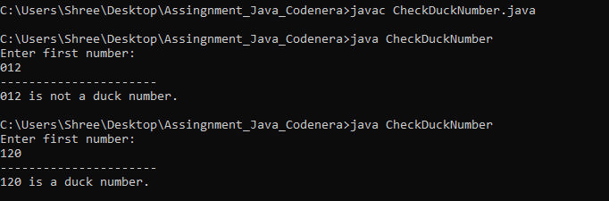

**5.** **Create a Java program to generate the first N prime numbers and calculate the sum of their squares.**

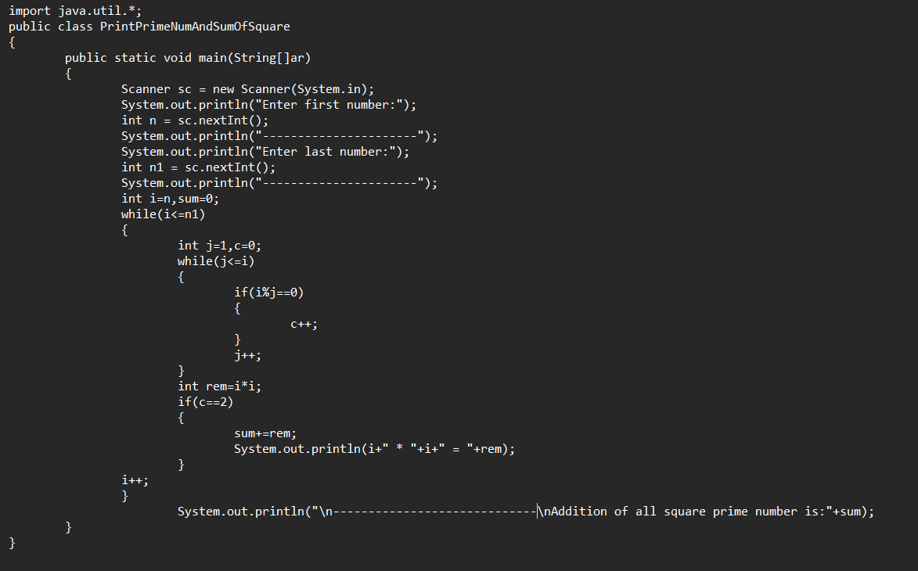

**Output:**

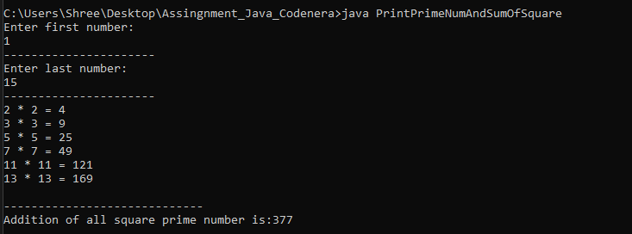

**6.** **Write a Java program to check if a given number is a palindrome and calculate the sum of its digits.**

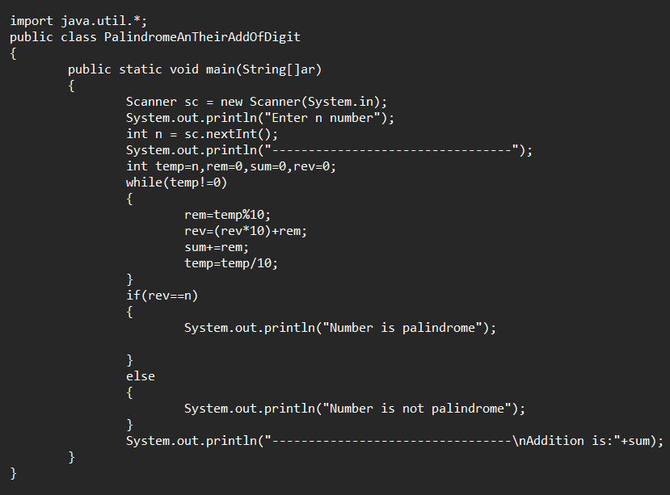

**Output:**

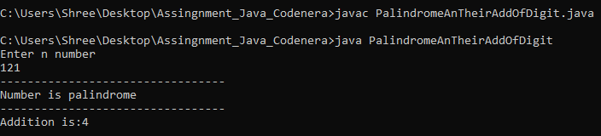

**7.** **Write a program to print the prime series between 10-20, but only till two digit from starting and find the sum of those two numbers.**

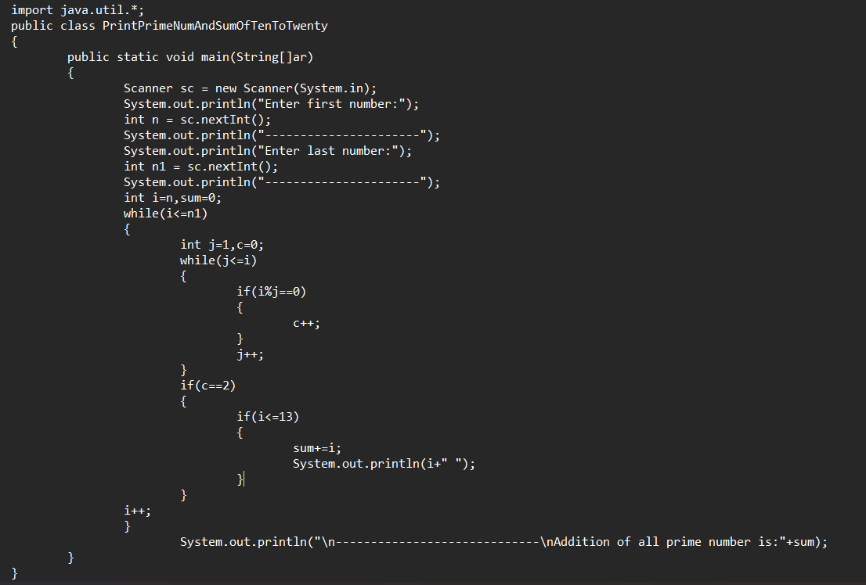

**Output:**

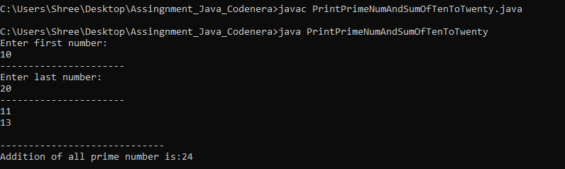

**8. Write a Java program to generate the prime numbers between 500 and 600, but only consider the prime numbers where the sum of their digits is a multiple of 3. Print the list of those prime numbers.**

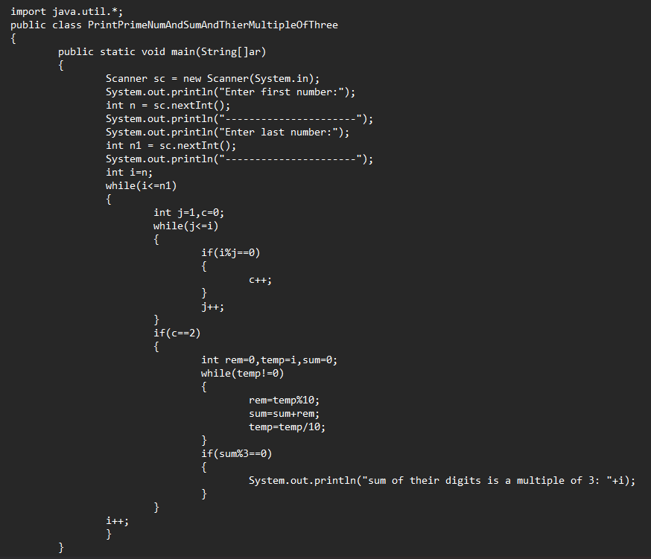

**Output:**

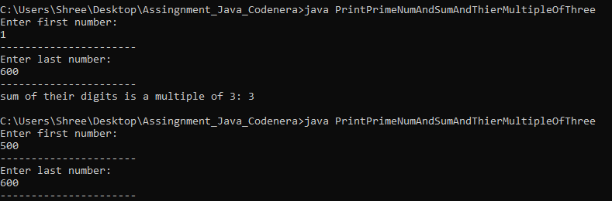

**9. Write a java program to generate the palindrome number between given range, if the element is palindrome find the sum of the element, if not then find the average of the element.**

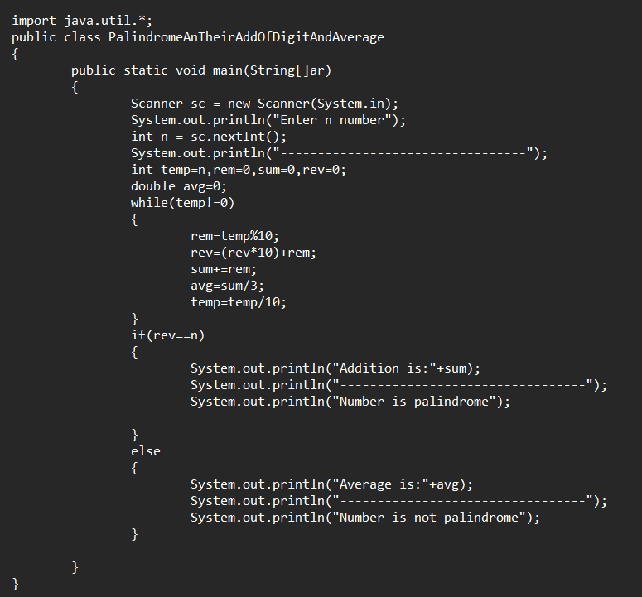

**Output:**

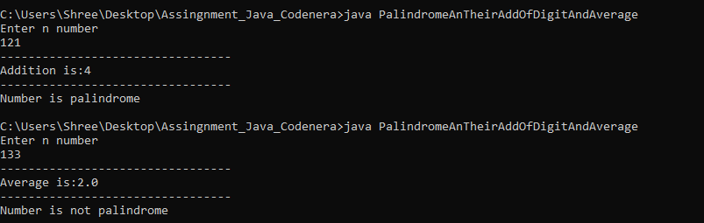

**10. Pattern Pyramid.**

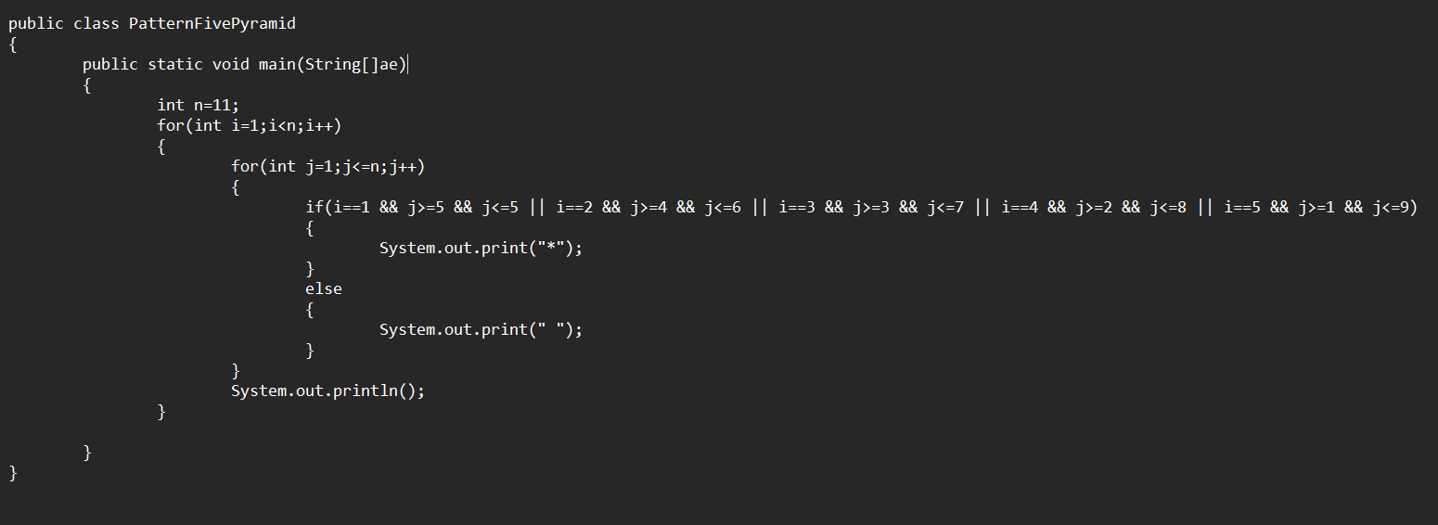

**Output:**

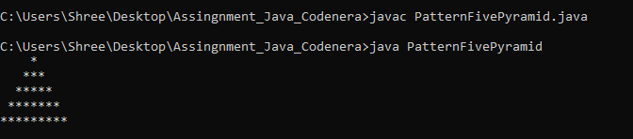

**11. Pattern Reverse Pyramid.**

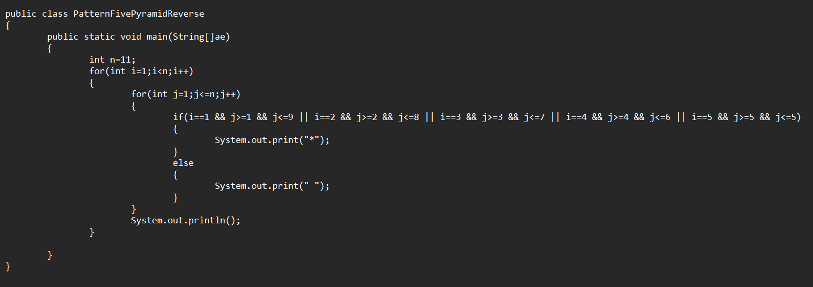

**Output:**

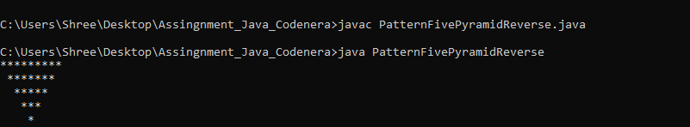

**12. Pattern.**

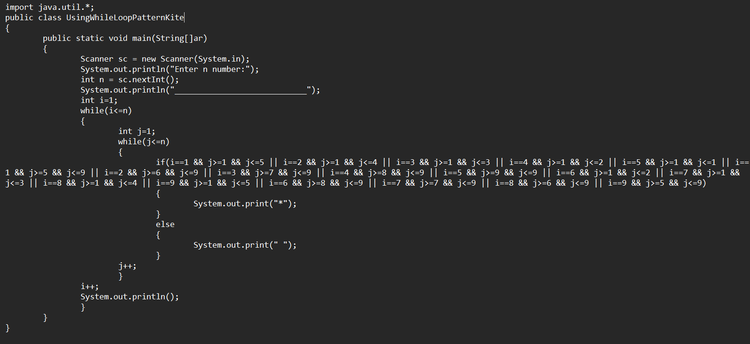

**Output:**

